Task 1
a.
There are many skills which will help you through your studying that will be able to be transferred for employment. Transferable skills are also known as “soft skills”. [1]
There are many skills that are classed as transferable, and each skill has its own importance, such as problem-solving, this is how you handle a problem that may be in front of you, regardless of what the “problem” is, how you handle it is what’s important, can you work through the problem calmly and effectively using logical thinking to solve the problem/issue?
Dependability is how dependent you are, are you able to do the work that has been set? Are you able to be depended on to ensure projects/assignments are finished even within certain circumstances?
Leadership and team management, though not always specific for a team, this an also apply if you are working independently as it is how you show if you are able to plan, an start a task without any major issues, which again problem solving comes into this as if there is an issue with independent work or team work, being able to navigate yourself and/your team to ensure the task is completed, prioritizing tasks and when working in a team, certain members my have different skill sets at a variety of levels, are you able to identify the skills set in members so you are able to assign a task that they would be more efficient in. [2]
Communication is a very vital skill not just in education and employment but in your personal life. Communication is how you are able to overcome the lack of ways of communication, or what you are communication, is it better to have a paper trail of the communication in question or is in person a better way to deal with a specific issue.
Overall developing these skills through out mu studies will help prepare me for employment in the IT sector. [3]
(wordcount 326)
b)
Artificial intelligence was first introduced as a concept in the 1950’s, now in 2026 there are many AI platforms, that help with many areas of life including professionally. [4]
In 2025 a study was conducted about the most popular AI apps worldwide, with ChatGPT ranking number one having over 700 million users. [5]
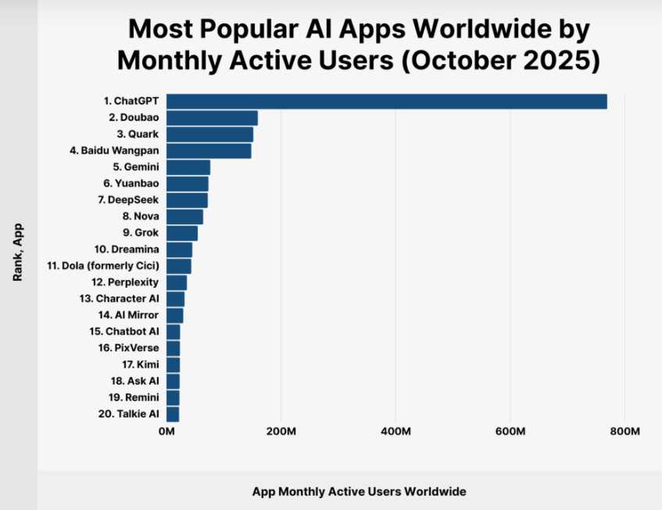
Figure 1. Screen capture of most popular AI apps worldwide by monthly active users, October 2025. Source: [5]
According to the above graph Chat GPT Is most popular by active users by a staggering amount.
Further researching AI platforms, I specifically looked what is “best” for students, and again (specifically choosing a UK site) Which again Chat GPT seemed to be most popular. With the reasoning because it is useful for a wide range of tasks. [6]
Chat GPT has an extension of itself named codex, which for coding, software engineering seems to be the best use of AI for my studies and possible future employability.
So, for snippets of code chat GPT is able to do, and it can do a wide variety of tasks (as mentioned earlier) codex is specifically designed for code building, with a more complex syntax understanding. [7]
(wordcount 196)
c)

